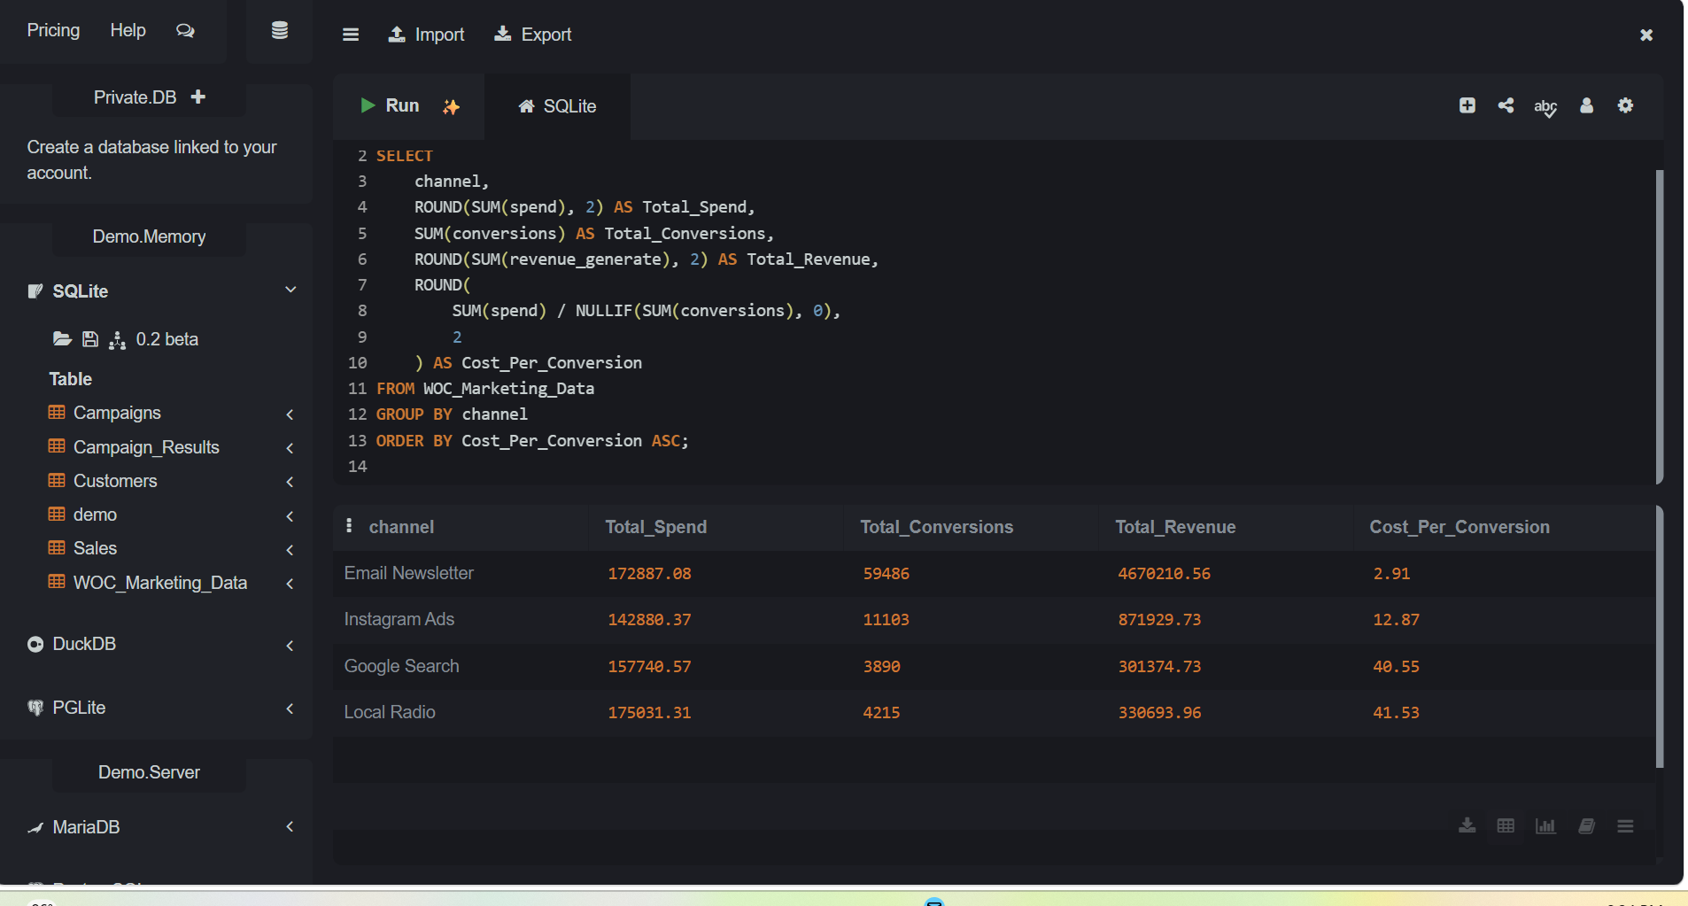
SELECT
channel,
ROUND(SUM(spend), 2) AS Total_Spend,
SUM(conversions) AS Total_Conversions,
ROUND(SUM(revenue_generate), 2) AS Total_Revenue,
ROUND(
SUM(spend) / NULLIF(SUM(conversions), 0),
2
) AS Cost_Per_Conversion
FROM WOC_Marketing_Data
GROUP BY channel
ORDER BY Cost_Per_Conversion ASC;

SELECT sql
FROM sqlite_master
WHERE type = 'table'
AND name IN (
'Campaigns',
'Customers',
'Sales',
'Campaign_Results'
);

